# Assembly function recognition

## Motivation

Function identification is a fundamental challenge in reverse engineering and binary program analysis. Many manifestations using in open source library to develop their products, this is one of the most prominent principles in software engineering called reuse. The open source code embedded in their products as one or more binaries files.

When we decode those binary, we get the original assembly code which is running in the product. These assembly code divided to few segments of assembly code, it’s called a function. The need arises for easier and faster code analysis. We want to identify library functions more easily (in automatic process) without reading them.

## Purpose

In my thesis, we answer the following question:

How to match (static analysis) between the assembly function (optimize function) taken from the product and the assembly function is known to compile in a debug environment taken from the debug environment.

We will answer this question regardless of the type of architecture.

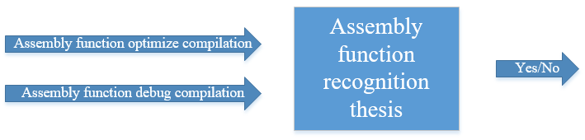

Description

As described above, after compiling an entire directory (e.g. libc.so) we get a binary file through which we want to identify all functions in the binary given by the manufacturer.

For example:

